Parent/Athlete LCPS ImPACT Baseline Testing Instructions

*Please familiarize yourself with these instructions prior to testing*

Computer Requirements and Troubleshooting Tips before you begin:

1. Make sure you are using Internet Explorer 6.0 and above or Firefox 1.5 or above and Safari for the MAC running OSX 10.2 and above. You must have Macromedia FLASH PLAYER 10.0 or newer installed. You can download FLASH PLAYER at www.adobe.com
2. Make sure your computer is plugged into an electrical outlet.
3. Make sure Pop-up blockers are turned off.
4. Make sure all other browser tabs and programs are closed.
5. It is highly recommended you use an external mouse if available.
6. Make sure you have your ImPACT Customer ID code ready.
Testing Location and Environment:
1. Make sure your test environment is quiet and distraction-free.
2. Make sure you’re well-rested and have had something to eat and drink to prepare your brain.
3. Make sure cell phones and other devices are turned off or away from the testing area.
4. Make sure you’re sitting at a table or desk with a flat hard surface.
General Instructions for Testing:
1. Work as quickly and accurately as possible. This is not a PASS/FAIL test, but it is timed and must be completed in one sitting, with no pauses or breaks.
2. Please put forth your best effort. If someone else takes the test or the test is done without full effort, this may impede the ability of medical providers to accurately track your recovery. This test is another tool we use to help you return to sports as quickly and safely as possible.
3. If the test does not reflect your best work, you may have to re-take it.
4. Find the email that contains your unique testing link. (Note: it may have gone to your spam folder). Here is the link: www.impacttestonline.com/testing or https://www.impacttestonline.com/htmllauncher/
5. Below are screen shots that should look familiar and help you answer the questions correctly as you begin the test.

6. Make sure to read all of the instructions before starting a NEW TEST SECTION.

7. If the test shuts off at any point, please refer to the Computer Requirements and Troubleshooting Tips above and re-start the test.

Enter the Customer ID Code for your school and hit “Validate”
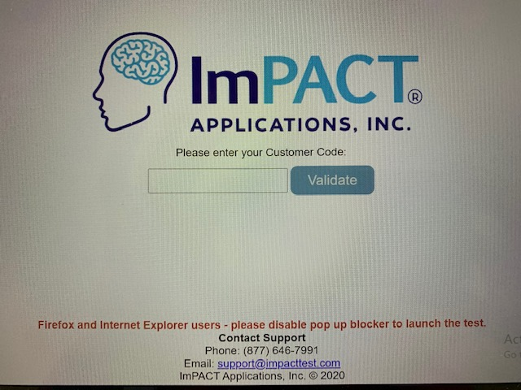
Select Language
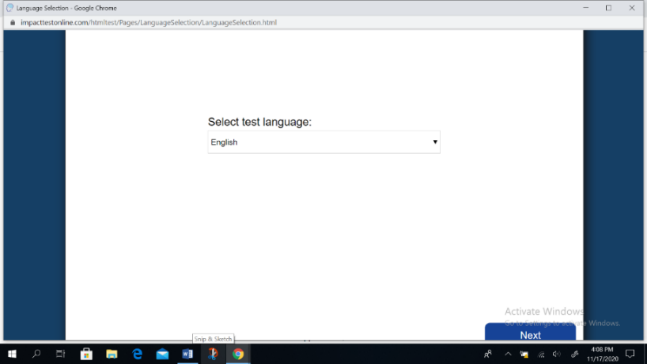
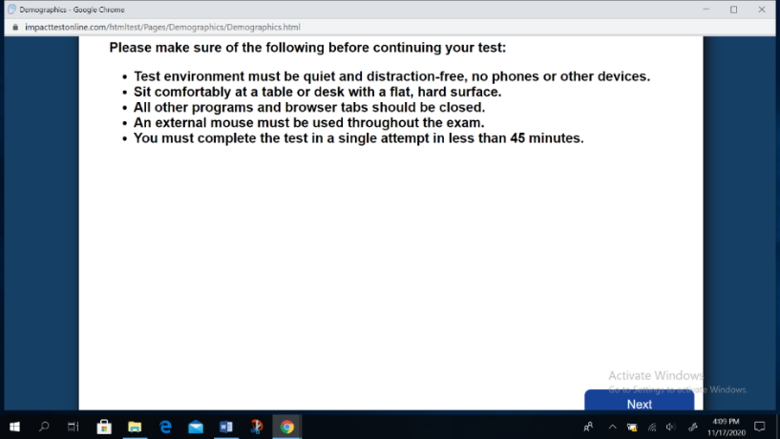
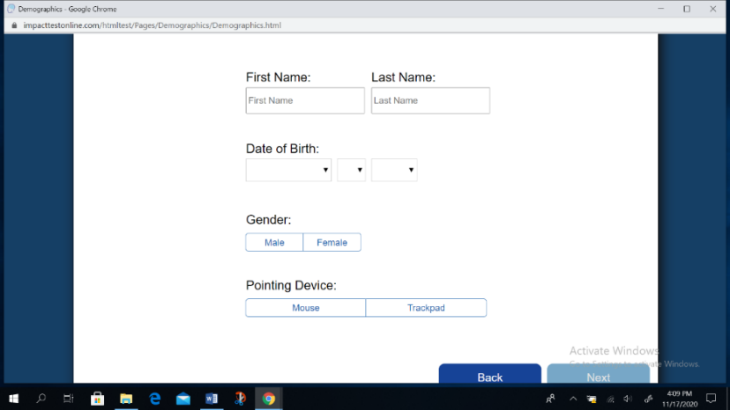
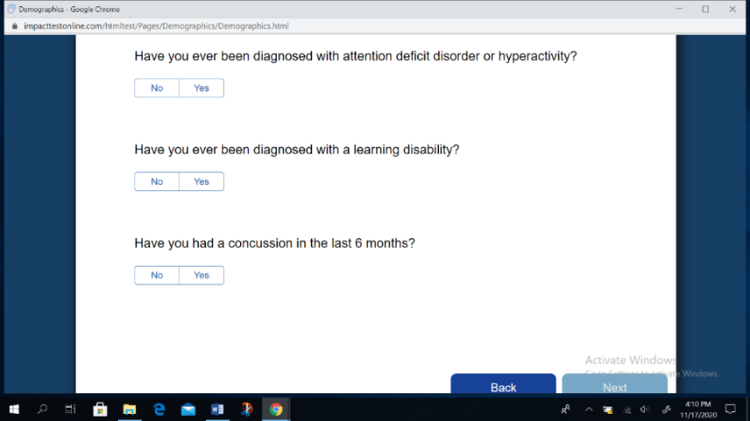
Click on “Enter Additional Demographics”
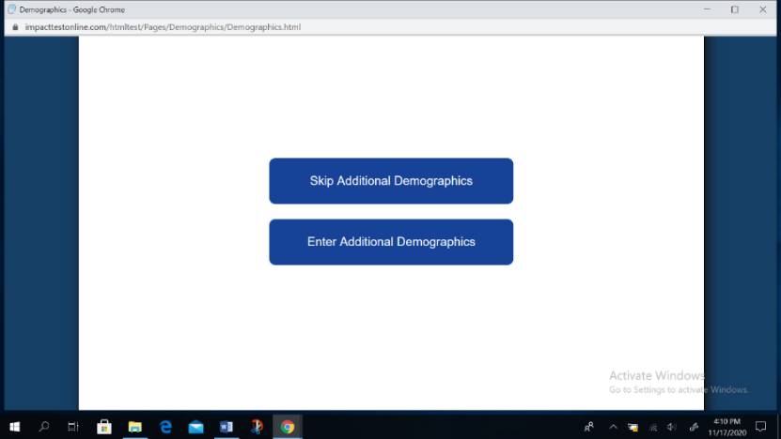
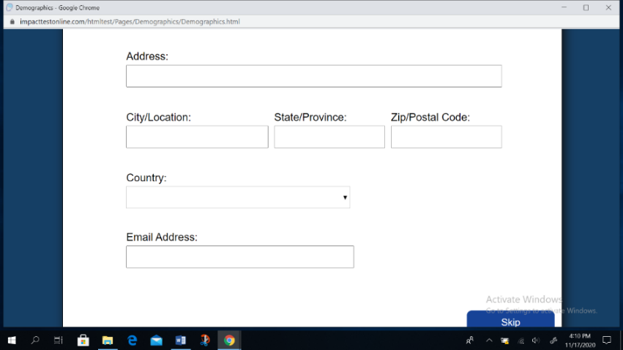
Leave second language blank if no other language is spoken at home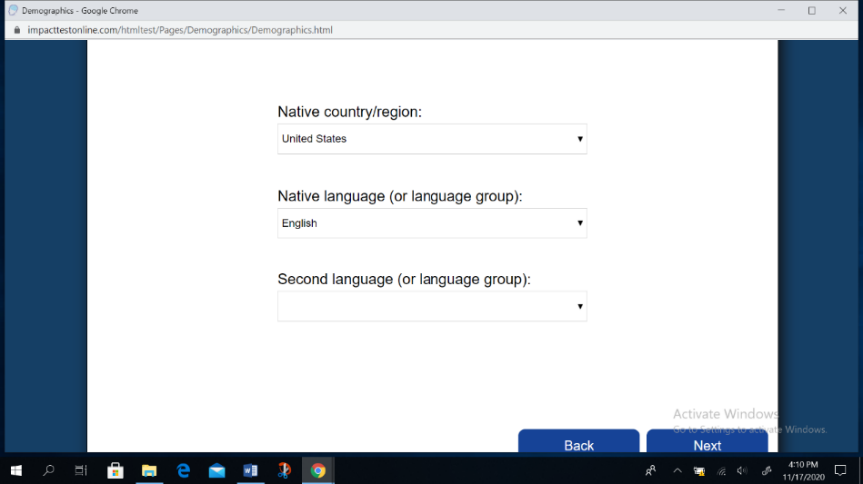
Under “Years of education completed” it’s your current grade MINUS 1
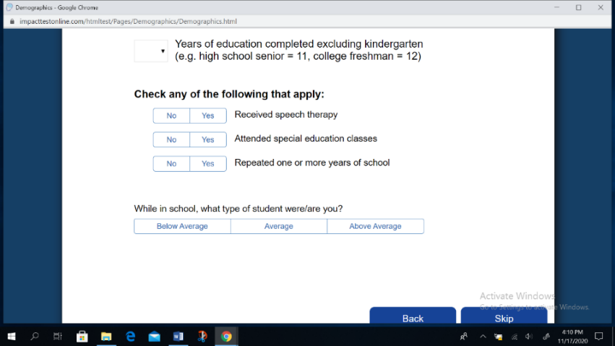
Type in your position for the primary sport you play this season
Years of experience = high school years, not including this year (freshmen = 0)
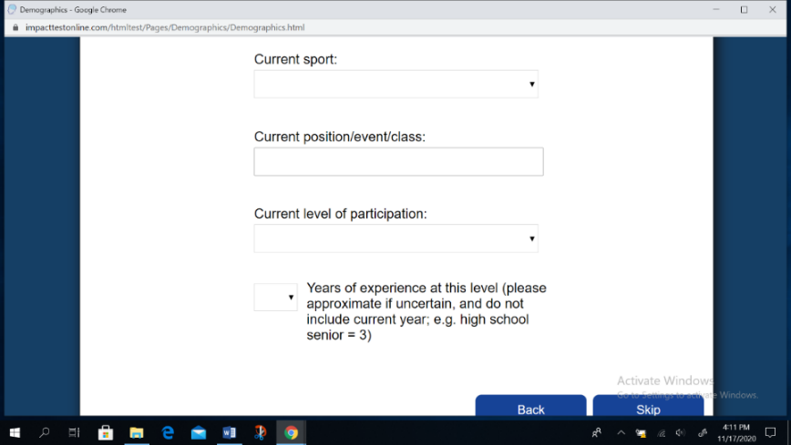
Select number of diagnosed concussions. If 0, then leave it at “0”
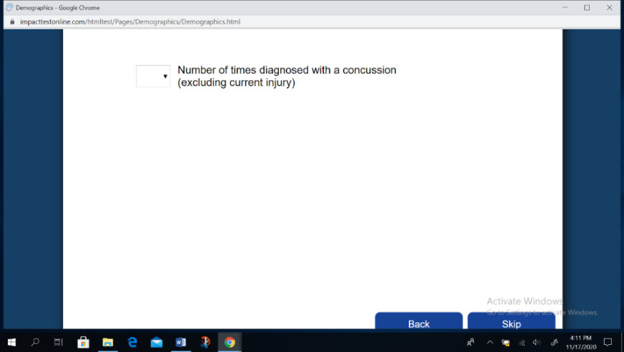

If 1 or more, complete the following questions
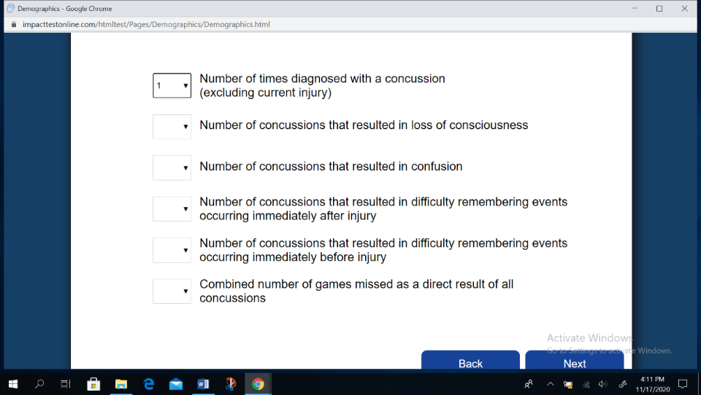
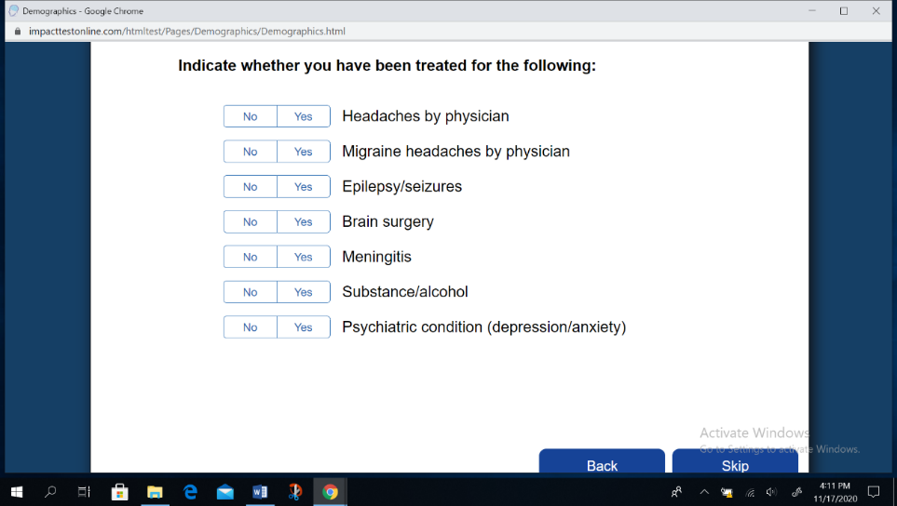
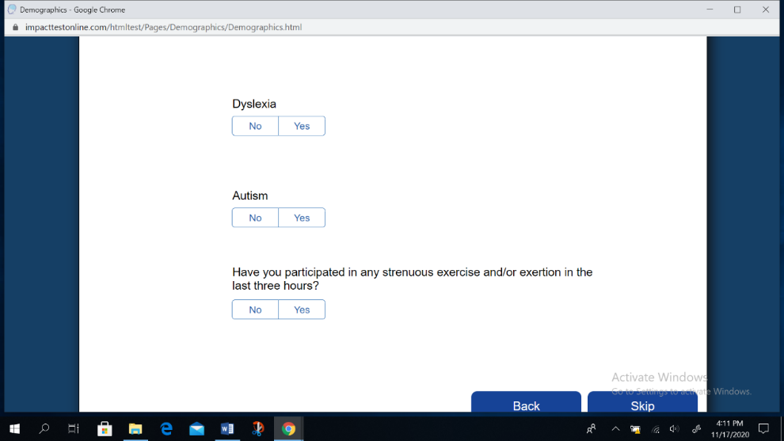

If you can’t remember the exact date of your last concussion put as close to it as you can;
*Don’t forget to answer Hours of Sleep Last Night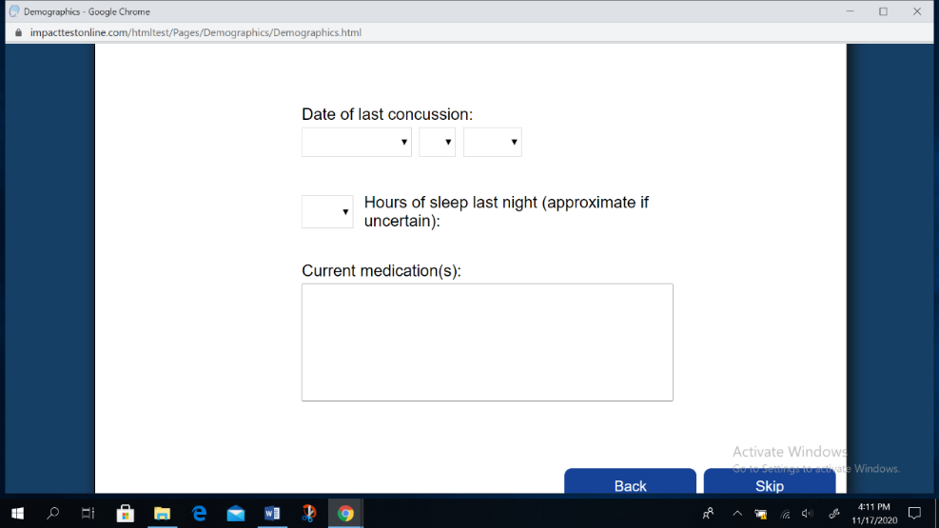
Following this screen, you will be asked to fill out Current Symptoms and Conditions on 4 consecutive screens; ANSWER EVERY QUESTION: “1” is very mild, “6” is severe
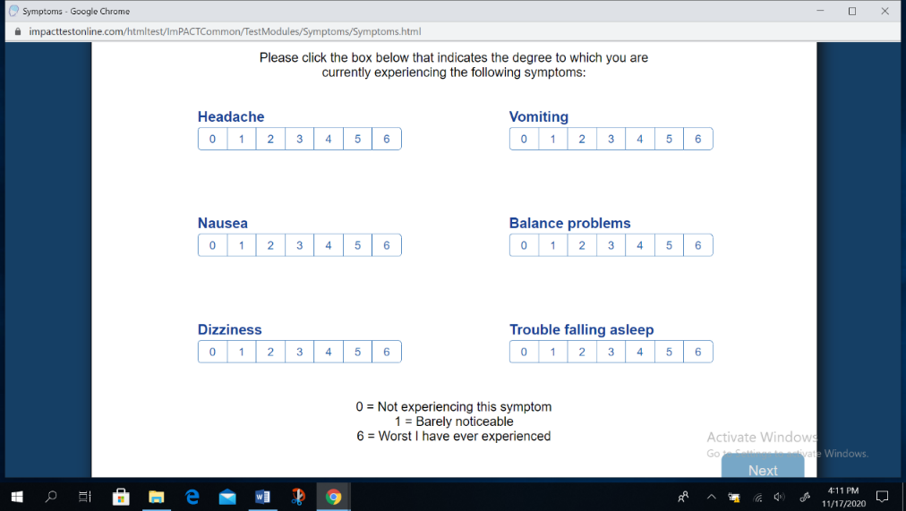
Screen you will see after the Current Symptoms and Conditions that signals the start of the TIMED Test. Once the test is complete you can close out all screens.
